By

Elikanti Harini - 23ECB0B33

Sakshi S Jangi -23ECB0B51

Sameera Rao - 23ECB0F21

# **Wireless AC Current Detector**

Submitted to

Dr. Ch. V. Rama Rao

Department of Electronics & communication Engineering

**National Institute of Technology Warangal**

**Table of Contents**

**1.Introduction**

**2.Description of the circuit**

**3.List of components**

**4.Experimentation**

**5.Applications**

**Introduction**

# 

Electricity can kill/severely injure people and cause damage to property. However, by taking simple precautions when working with/near electricity and electrical equipment we can significantly reduce the risk of injuries. In order to avoid damage, prior to working on an AC Mains switch board or a power supply, we need to check for AC Voltage. Since we can't isolate the device from the supply wires, we should check for an AC voltage without any contact. Therefore, we use a Wireless AC current/voltage Detector.

**Description of the circuit**

In this 3 stage cascaded circuit constructed with BC547 transistor ,the base of the first transistor is connected with wire spiral which detects EMF(electromagnetic field )on the AC supply carrying wire, and signal from this transistor is given to the third transistor’s base, which has larger bias than first transistor and so it can amplify the input signal and gives to the second transistor’s base .Here the second transistor acts as a switch and when signal reaches its base it becomes closed switch and connects buzzer, LED with bias, if no signal then the second transistor stays in off condition

**List of components**

1. Transistors BC547 – 3

2. Resistor – 220 ohms

3. Resistor- 68k ohms

4. Resistor- 1M ohms

5. LED – Red

6. Buzzer

7. 9V Battery

8. Battery Connector-Snap

9. Single Layer PCB

**Experimentation**

The main part of this simple AC current detector circuit is the transistor, which acts as an amplifier and switch. Buzzer produces sound alert when the wire spiral detects electromagnetic field on wire carrying AC supply. Also, the LED glows to indicate the AC current flow.

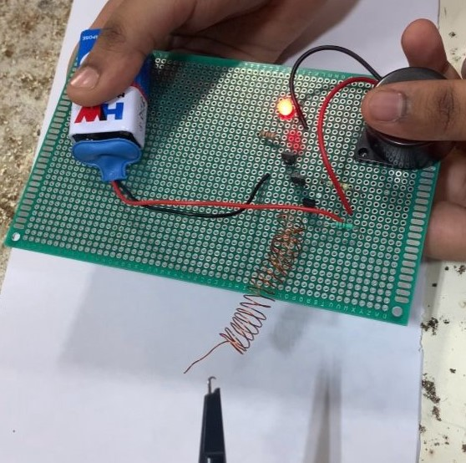

**Applications**

**\*AC power presence detection**

**\*HVAC Automation**

**\*Machine on/off state Detection**